**PROJECT: Developing a Backend Admin for Learner’s Academy.**

**Developer Name:** PUTTA SAI KUMAR

This document contains contents for:

* Sprint planning
* Project Description
* Flow of the Application
* Core concepts used in project
* Conclusions.

**1.SPRINT LEARNING:**

The project is planned to be completed in 2 sprints.

Tasks assumed to be completed in the sprint are:

· Creating the flow of the application

· Initializing git repository to track changes as development progresses.

· Writing the Dynamic web project program to fulfill the requirements of the project.

· Testing the Dynamic web project program with different kinds of User input

· Pushing code to GitHub

· Creating this specification document highlighting application capabilities, appearance, and user interactions.

**2.Project Description:**

* Set up a master list of all the subjects for all the classes.
* Set up a master list of all the teachers.
* Set up a master list of all the classes.
* Assign classes for subjects from the master list.

Assign teachers to a class for a subject (A teacher can be assigned to different classes for different subjects).

* Get a master list of students (Each student must be assigned to a single class)
* There will be an option to view a Class Report which will show all the information about the class, such as the list of students, subjects, and teachers.

**3.Application Flow:**

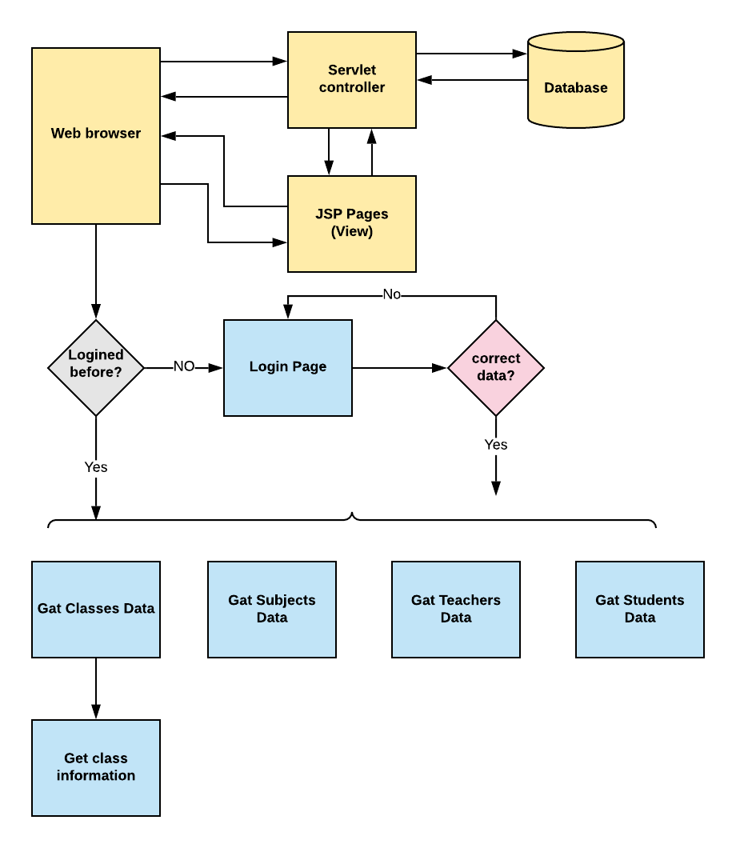

**4.Core concepts used in project:**

● Eclipse IDE to code for the application.  
● web pages, databases, and others  
● SQL: To create tables for admin, classes, students, and other specifics  
● Search and Sort techniques: Data structures used for the project

Apache tomcat for run on server and designing html pages

Conclusion:

* This project is designed for displaying the backend admin for learners academy.